# JS Advanced Regular Exam – 19 Feb 2022

# Problem 1. Work Process

**Environment Specifics**

Please, be aware that every JS environment may **behave differently** when executing code. Certain things that work in the browser are not supported in **Node.js**, which is the environment used by **Judge**.

The following actions are **NOT** supported:

* **.forEach()** with **NodeList** (returned by **querySelector()** and **querySelectorAll()**)
* **.forEach()** with **HTMLCollection** (returned by **getElementsByClassName()** and **element.children**)
* Using the **spread-operator** (**...**) to convert a **NodeList** into an array
* **append()** in Judge (use only **appendChild()**)
* **replaceWith()** in Judge
* **replaceAll()** in Judge
* **closest()** in Judge
* **replaceChildren()**
* Always turn the collection into a **JS array** (forEach, forOf, et.)

If you want to perform these operations, you may use **Array.from()** to first convert the collection into an array.

Use the provided skeleton to solve this problem.

**Note**: You **can't** and you have no permission to **change** directly the given HTML code (index.html file).



**Your Task**

**Write the missing JavaScript code** to make the **Work Process** work as expected:

# Getting the information from the hired form



* **All fields** are **non**-**empty** **strings**. If any of them are empty, the program should not do anything.
* When you click the **["**Hire Worker**"**] button, the information from the input fields must be added to the **table** and **then clear input fields**.
* Each input must be saved in **td** tag and the end must be added buttons – **Fired** and **Edit.** Look at the example below.
* The HTML structure looks like this:

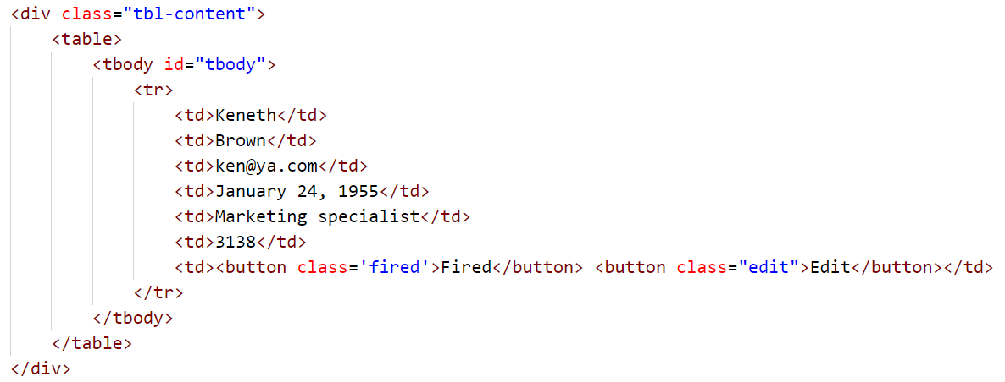



* When the record is savedthe **salary** must be **added** to the **budget** message. The sum should be rounded to the second decimal number:

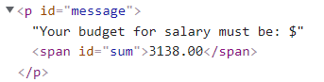



# Edit information for workers

* When the **["Edit"]** button is clicked, the information from the table must be sent to the input’s fields and the record should be deleted from the table.
* The **salary** for the **edit** worker should be **taken out** from the **budget**.



* After editing the information make a new record to the table with updated information.



# Fired workers

* When you click the **["Fired"]** button, the record must be **deleted** from the **table**;
* The **salary** for the fired worker should be **taken out** from the **budget**.



**Submission**

Submit only your **solve()** function.

*GOOD LUCK… ☺*